# Political Juggernauts: A Quantitative Analysis of Candidates in the 2019 Lok Sabha

# NM Id: NM2023TMID09498

# INTRODUCTION

# Overview

* In the 2019 Lok Sabha elections, thousands of candidates from various political parties and independent backgrounds contested for seats in the lower house of India's parliament. The elections were held over multiple phases, allowing for diverse representation and a deep examination of candidate profiles.

# Purpose

* Understand the diversity of candidates in terms of age, gender, educational background, and professional experience.

1. **Problem Definition & Design Thinking**

# Empathy Map

# 

# Ideation & Brainstorming Map

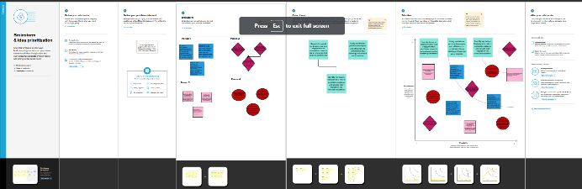

# RESULTS

# 

# 

# ADVANTAGES & DISADVANTAGES

# Advantages:

* Candidates with previous experience in Lok Sabha might have name recognition and a track record to run on.
* Candidates from well-established parties often benefit from the party's resources and voter base.
* Educational background and relevant experience can enhance a candidate's appeal.

# Disadvantages:

# Being an incumbent can also be a disadvantage if there

# is public dissatisfaction with their performance.

# Candidates with criminal cases or corruption allegations

# may face public skepticism.

# Regional politics and alliances can significantly impact a

# candidate's chances.

# APPLICATIONS

# Data Collect

# Data Preprocessing

# Exploratory Data Analysis (EDA)

# Hypothesis Testing

# Interpretation

# 

# CONCLUSION

* The analysis could reveal the age, gender, education level, and other demographic characteristics of candidates. This can shed light on the diversity or lack thereof in the candidate pool. Quantitative data on candidates with criminal records can highlight the prevalence of such candidates in the election.

# FUTURE SCOPE

* Study how demographics, social factors, and regional variations influence voter choices. This can be useful for political parties to tailor their campaigns.
* Continue to analyze the profiles of candidates, including their education, criminal records, and previous political experience. This can help in assessing the quality of candidates in future elections.
* Create visually appealing and informative data visualizations to make your findings more accessible to a broader audience.